**Hash table – each table entry has an Slist**

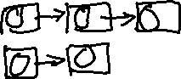

**Is an el_t object**

**== checks only the key parts of the objects**

**So, key:123 name: blank age: blank will match key:123 name: Mary age:22**